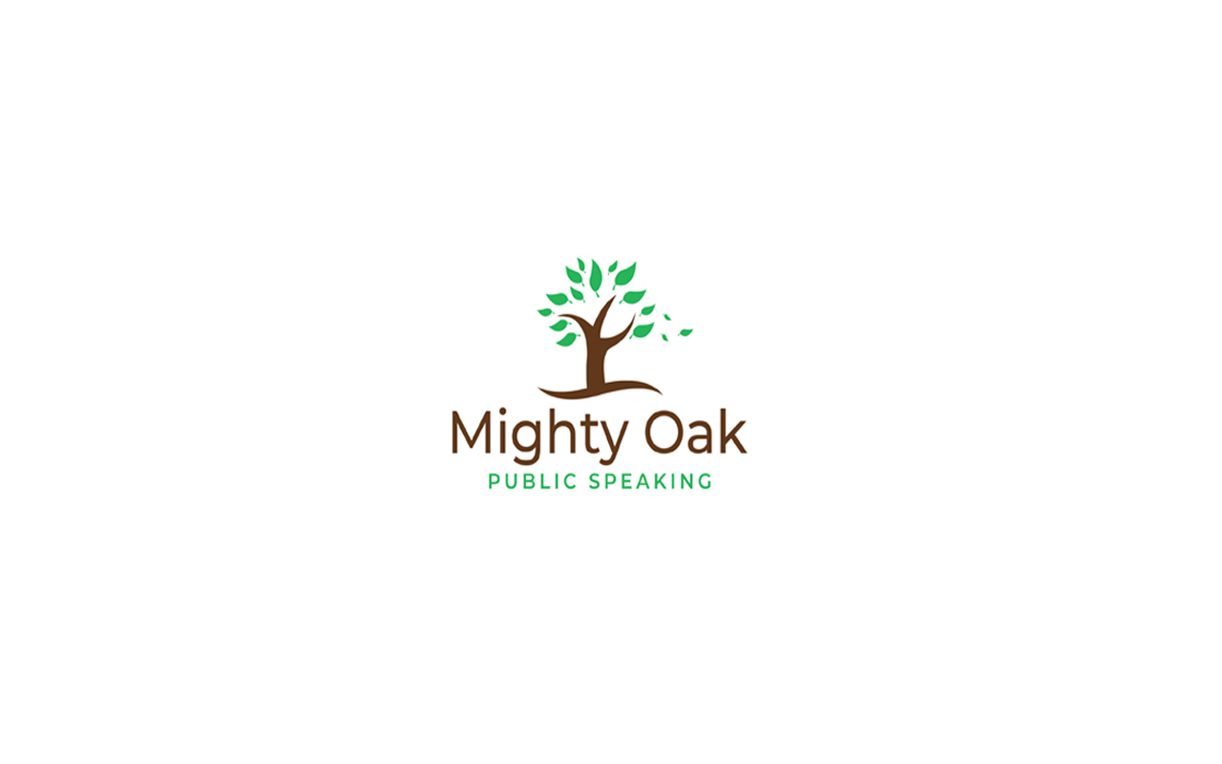

Signature of Parent

Date

Printed name of Parent

Permission form

Please tick one of the three options below

and fill in the remainder of the form

Please note that regretfully, we will not view

the competition entry if this form is not filled in.

|  |  |
| --- | --- |
| I give permission for the video of me delivering my speech, which I am sending over , to be viewed and assessed for the purposes of the competition. I also consent for my video to be uploaded onto the Mighty Oak website as an exhibition or winners speech, if so deemed by the Mighty Oak teachers. |  |
| I give permission for the video of me delivering my speech, which I am sending over , to be viewed and assessed for the purposes of the competition. I also consent for parts of my video to be used for teaching purposes both on and off line. ( Positive attributes only) |  |
| I give permission for the video of me delivering my speech, which I am sending over, to be viewed and assessed for the purposes of the competition only. This can viewed by the Mighty Oak teachers. After which, I ask that it is immediately deleted. |  |
| Name of pupil |  |
| Name of parent or guardian |  |
| Parent or Teacher contact email address (and phone number if possible) |  |
| School |  |